Practical 13
Problem Definition
Create simple PHP JSON API endpoints for events or students and consume them using Fetch API. Perform list, add, update, and delete operations asynchronously without full page reload.
Code:-
Db.php:-
<?php
$conn = new mysqli("localhost", "root", "", "studenthub13");

if ($conn->connect_error) {
http_response_code(500);
die("Database connection failed");
}

$conn->set_charset("utf8mb4");
?>
Api.php:-
<?php
header("Content-Type: application/json; charset=UTF-8");

require_once "db.php";

$method = $_SERVER["REQUEST_METHOD"];

function sendResponse($data, $status = 200) {
http_response_code($status);
echo json_encode($data);
exit;
}

function getInput() {
$data = json_decode(file_get_contents("php://input"), true);
return is_array($data) ? $data : [];
}

try {
// LIST EVENTS
if ($method === "GET") {
$result = $conn->query(
"SELECT id, title, event_date, description
FROM events ORDER BY id DESC"
);

$events = [];

while ($row = $result->fetch_assoc()) {
$events[] = $row;
}

sendResponse($events);
}

// ADD EVENT
if ($method === "POST") {
$data = getInput();

$title = trim($data["title"] ?? "");
$date = $data["event_date"] ?? "";
$description = trim($data["description"] ?? "");

if ($title === "" || $date === "") {
sendResponse([
"success" => false,
"message" => "Title and date are required."
], 400);
}

$stmt = $conn->prepare(
"INSERT INTO events (title, event_date, description)
VALUES (?, ?, ?)"
);

$stmt->bind_param("sss", $title, $date, $description);
$stmt->execute();

sendResponse([
"success" => true,
"message" => "Event added successfully.",
"id" => $conn->insert_id
], 201);
}

// UPDATE EVENT
if ($method === "PUT") {
$data = getInput();

$id = filter_var(
$data["id"] ?? null,
FILTER_VALIDATE_INT
);

$title = trim($data["title"] ?? "");
$date = $data["event_date"] ?? "";
$description = trim($data["description"] ?? "");

if (!$id || $title === "" || $date === "") {
sendResponse([
"success" => false,
"message" => "Valid ID, title and date are required."
], 400);
}

$stmt = $conn->prepare(
"UPDATE events
SET title = ?, event_date = ?, description = ?
WHERE id = ?"
);

$stmt->bind_param("sssi", $title, $date, $description, $id);
$stmt->execute();

if ($stmt->affected_rows === 0) {
$check = $conn->prepare(
"SELECT id FROM events WHERE id = ?"
);
$check->bind_param("i", $id);
$check->execute();

if ($check->get_result()->num_rows === 0) {
sendResponse([
"success" => false,
"message" => "Event not found."
], 404);
}
}

sendResponse([
"success" => true,
"message" => "Event updated successfully."
]);
}

// DELETE EVENT
if ($method === "DELETE") {
$data = getInput();

$id = filter_var(
$data["id"] ?? null,
FILTER_VALIDATE_INT
);

if (!$id) {
sendResponse([
"success" => false,
"message" => "Valid event ID is required."
], 400);
}

$stmt = $conn->prepare(
"DELETE FROM events WHERE id = ?"
);

$stmt->bind_param("i", $id);
$stmt->execute();

if ($stmt->affected_rows === 0) {
sendResponse([
"success" => false,
"message" => "Event not found."
], 404);
}

sendResponse([
"success" => true,
"message" => "Event deleted successfully."
]);
}

header("Allow: GET, POST, PUT, DELETE");
sendResponse([
"success" => false,
"message" => "Method not allowed."
], 405);

} catch (Throwable $e) {
sendResponse([
"success" => false,
"message" => "A server error occurred."
], 500);
}
?>
Index.php:-
<!DOCTYPE html>
<html lang="en">
<head>
<meta charset="UTF-8">
<meta name="viewport" content="width=device-width, initial-scale=1.0">
<title>StudentHub - Event Management</title>

<style>
* {
box-sizing: border-box;
}

body {
font-family: Arial, sans-serif;
background: #f0f4f8;
margin: 0;
padding: 20px;
}

.container {
max-width: 900px;
margin: 30px auto;
background: white;
padding: 25px;
border-radius: 12px;
box-shadow: 0 3px 12px #ccc;
}

h1, h2 {
text-align: center;
color: #153e75;
}

input, textarea, button {
width: 100%;
padding: 11px;
margin: 8px 0;
font-size: 15px;
}

input, textarea {
border: 1px solid #bbb;
border-radius: 5px;
}

button {
border: none;
border-radius: 5px;
color: white;
background: #1769aa;
cursor: pointer;
}

button:hover {
opacity: 0.85;
}

.cancel {
background: #666;
}

.edit {
background: #e49b12;
}

.delete {
background: #d93636;
}

.event {
background: #f7f9fc;
border: 1px solid #ddd;
border-left: 5px solid #1769aa;
padding: 15px;
margin: 12px 0;
border-radius: 5px;
overflow-wrap: anywhere;
}

.event button {
width: auto;
padding: 9px 16px;
margin-right: 5px;
}

#message {
text-align: center;
font-weight: bold;
color: #16803c;
}

.error {
color: #c62828 !important;
}

@media (max-width: 600px) {
body {
padding: 8px;
}

.container {
padding: 15px;
margin: 10px auto;
}

.event button {
width: 100%;
}
}
</style>
</head>

<body>

<div class="container">
<h1>StudentHub Event Management</h1>

<p id="message" role="status" aria-live="polite"></p>

<h2 id="formTitle">Add New Event</h2>

<form id="eventForm">
<input type="hidden" id="eventId">

<label for="title">Event Title</label>
<input type="text" id="title" required maxlength="150">

<label for="event_date">Event Date</label>
<input type="date" id="event_date" required>

<label for="description">Description</label>
<textarea id="description" rows="3"></textarea>

<button type="submit" id="submitBtn">Add Event</button>
<button type="button" class="cancel"
id="cancelBtn" hidden>Cancel Edit</button>
</form>

<hr>

<h2>All Events</h2>
<div id="eventList">Loading events...</div>
</div>

<script src="script.js"></script>
</body>
</html>
Script.js:-
const API = "api.php";

const form = document.getElementById("eventForm");
const eventList = document.getElementById("eventList");
const message = document.getElementById("message");
const eventId = document.getElementById("eventId");
const title = document.getElementById("title");
const eventDate = document.getElementById("event_date");
const description = document.getElementById("description");
const submitBtn = document.getElementById("submitBtn");
const cancelBtn = document.getElementById("cancelBtn");
const formTitle = document.getElementById("formTitle");

// Display success or error messages
function showMessage(text, isError = false) {
message.textContent = text;
message.classList.toggle("error", isError);
}

// Send a request to the PHP API
async function requestAPI(method, data = null) {
const options = {
method: method,
headers: {
"Content-Type": "application/json"
}
};

if (data !== null) {
options.body = JSON.stringify(data);
}

const response = await fetch(API, options);
const result = await response.json();

if (!response.ok) {
throw new Error(result.message || "Request failed.");
}

return result;
}

// Safely display text received from the server
function escapeHTML(value) {
return String(value ?? "").replace(/[&<>"']/g, char => ({
"&": "&amp;",
"<": "&lt;",
">": "&gt;",
'"': "&quot;",
"'": "&#39;"
})[char]);
}

// LIST: Fetch and display all events
async function loadEvents() {
eventList.textContent = "Loading events...";

try {
const events = await requestAPI("GET");

eventList.replaceChildren();

if (events.length === 0) {
eventList.textContent = "No events found.";
return;
}

events.forEach(event => {
const card = document.createElement("div");
card.className = "event";

card.innerHTML = `
<h3>${escapeHTML(event.title)}</h3>
<p><strong>Date:</strong>
${escapeHTML(event.event_date)}</p>
<p>${escapeHTML(event.description || "No description")}</p>
<button type="button" class="edit"
data-action="edit" data-id="${Number(event.id)}">
Edit
</button>
<button type="button" class="delete"
data-action="delete" data-id="${Number(event.id)}">
Delete
</button>
`;

eventList.appendChild(card);
});
} catch (error) {
eventList.textContent = "Unable to load events.";
showMessage(error.message, true);
}
}

// ADD and UPDATE: Submit without page reload
form.addEventListener("submit", async function (event) {
event.preventDefault();

const id = eventId.value;

const data = {
title: title.value.trim(),
event_date: eventDate.value,
description: description.value.trim()
};

if (!data.title || !data.event_date) {
showMessage("Please enter the title and date.", true);
return;
}

const method = id ? "PUT" : "POST";

if (id) {
data.id = Number(id);
}

submitBtn.disabled = true;

try {
const result = await requestAPI(method, data);

showMessage(result.message);
resetForm();
await loadEvents();
} catch (error) {
showMessage(error.message, true);
} finally {
submitBtn.disabled = false;
}
});

// Handle Edit and Delete button clicks
eventList.addEventListener("click", async function (event) {
const button = event.target.closest("button[data-action]");

if (!button) return;

const id = Number(button.dataset.id);
const action = button.dataset.action;

try {
const events = await requestAPI("GET");
const selectedEvent = events.find(item => Number(item.id) === id);

if (!selectedEvent) {
showMessage("Event not found.", true);
await loadEvents();
return;
}

// EDIT: Fill form with existing values
if (action === "edit") {
eventId.value = selectedEvent.id;
title.value = selectedEvent.title;
eventDate.value = selectedEvent.event_date;
description.value = selectedEvent.description || "";

formTitle.textContent = "Update Event";
submitBtn.textContent = "Update Event";
cancelBtn.hidden = false;

title.focus();
}

// DELETE: Ask for confirmation
if (action === "delete") {
if (!confirm("Are you sure you want to delete this event?")) {
return;
}

const result = await requestAPI("DELETE", { id });

showMessage(result.message);
await loadEvents();
}
} catch (error) {
showMessage(error.message, true);
}
});

// Cancel editing and clear the form
function resetForm() {
form.reset();
eventId.value = "";
formTitle.textContent = "Add New Event";
submitBtn.textContent = "Add Event";
cancelBtn.hidden = true;
}

cancelBtn.addEventListener("click", resetForm);

// Load events when the page first opens
loadEvents();
Screenshot:-
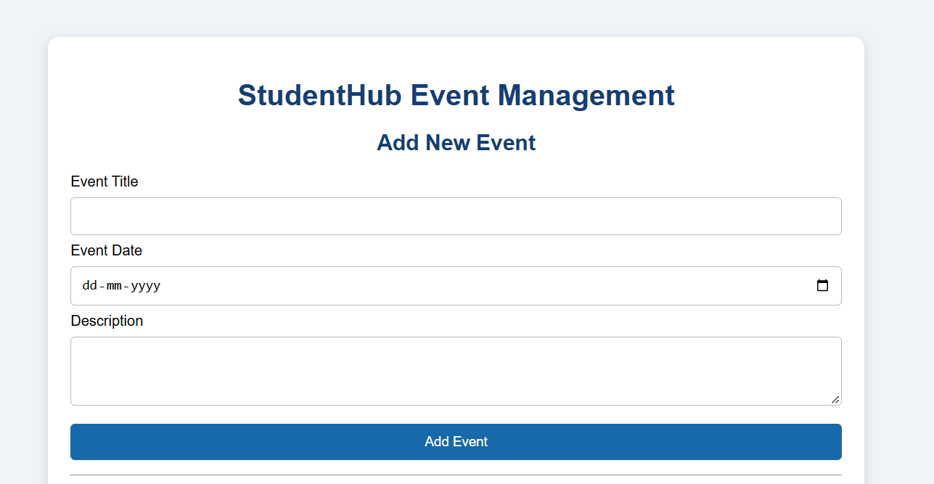

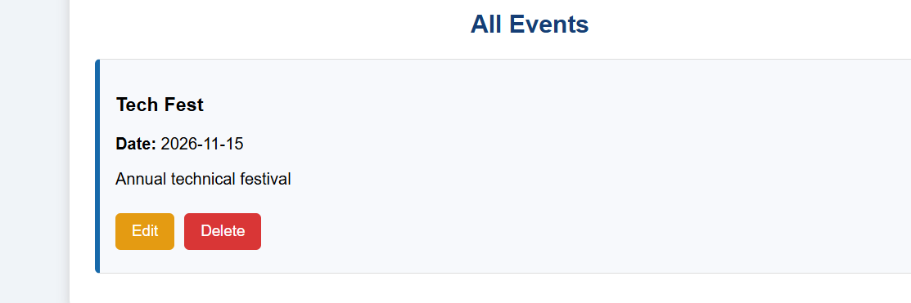
Enter a new event:-
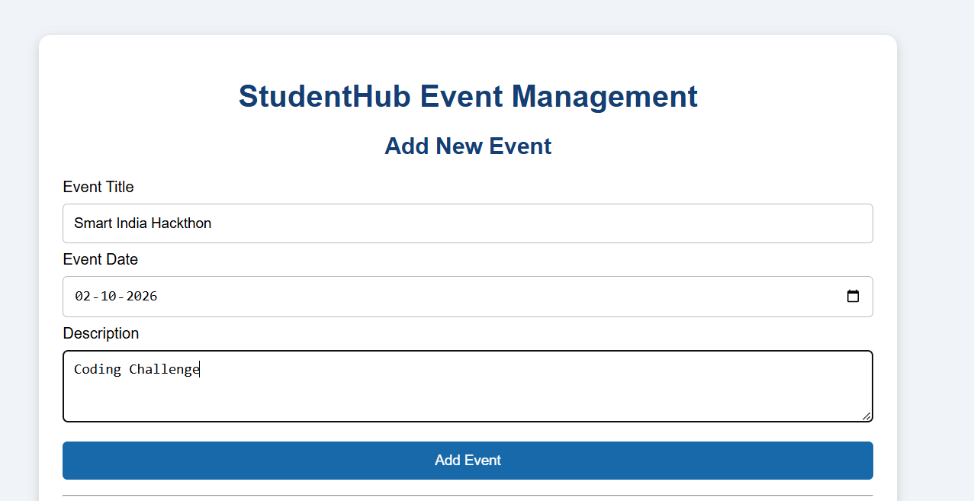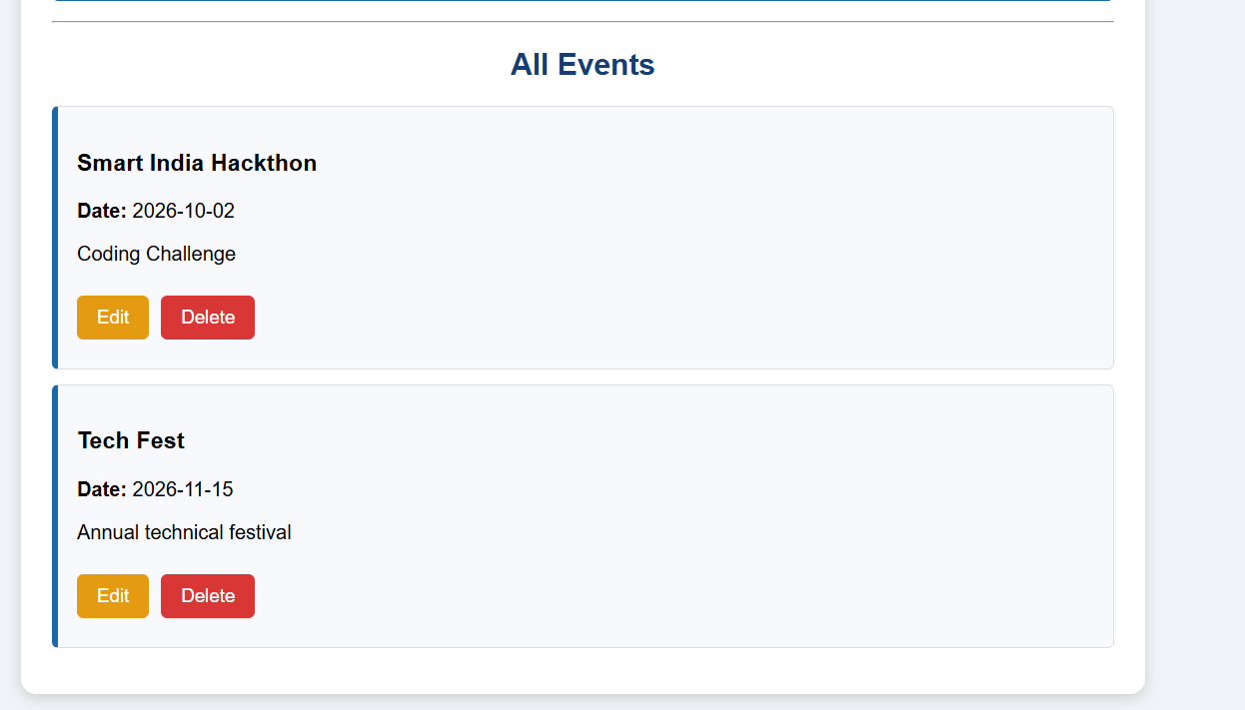
Edit an event detail:-
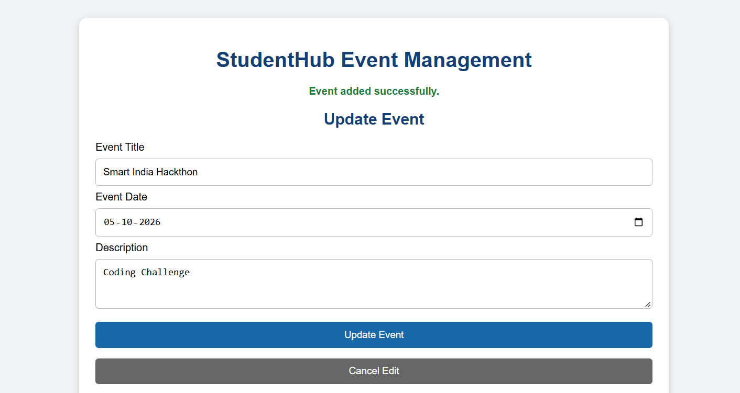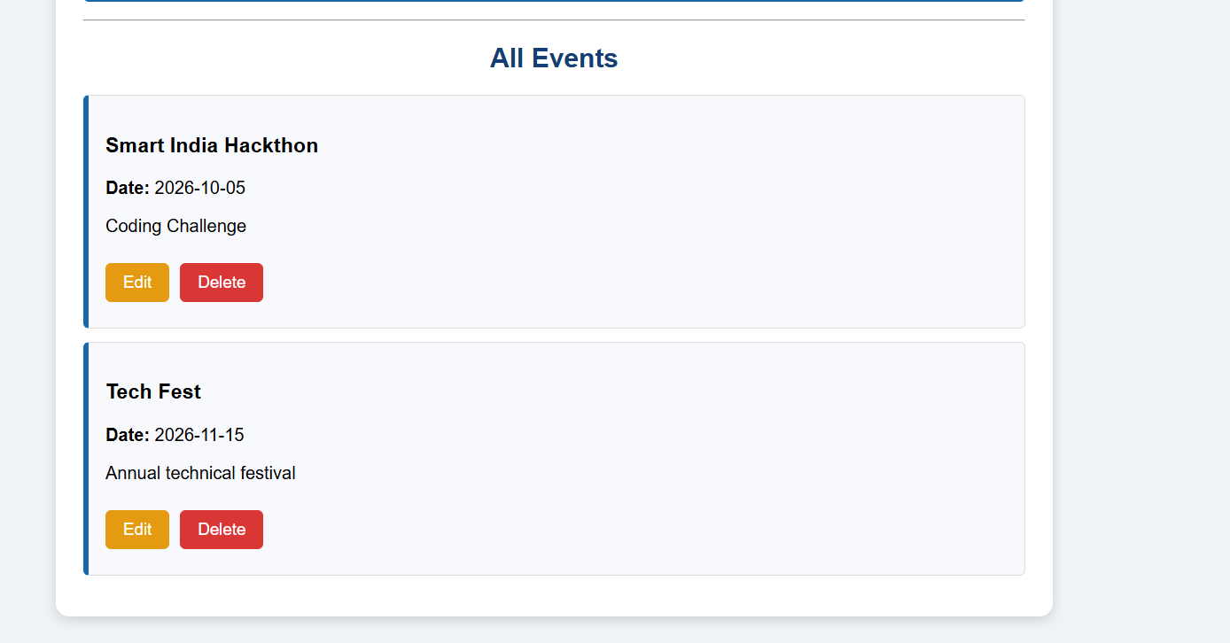
Delete an event:-
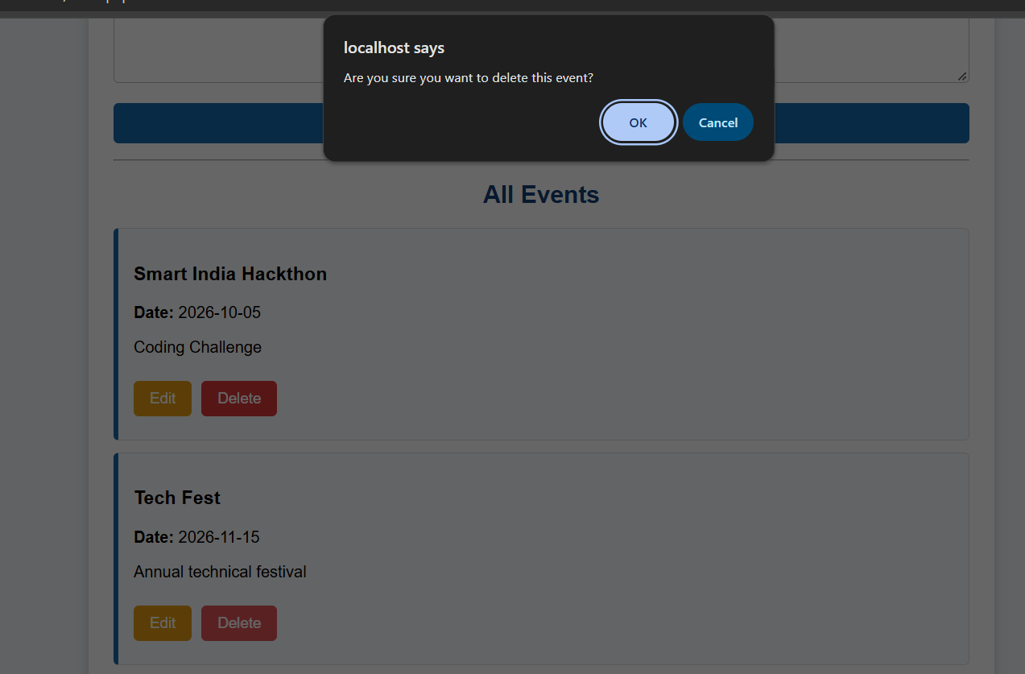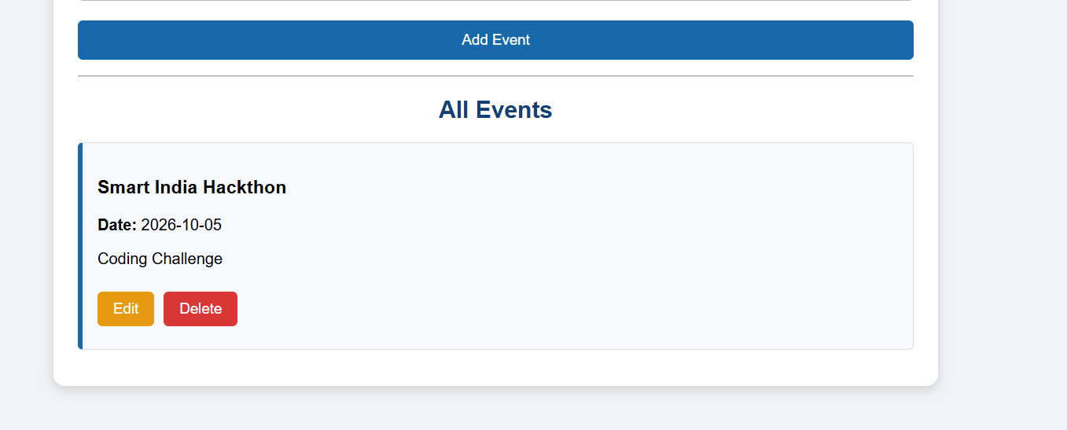
Key Questions:-
1. Do PHP endpoints return valid JSON responses?
Yes. The api.php file returns responses using json_encode(). It sends event data and success or error messages in JSON format, which can be processed by JavaScript Fetch API.
2. Are GET and POST requests handled properly?
Yes. The GET request retrieves and displays all events from the database, while the POST request adds a new event. PUT is used to update events, and DELETE is used to remove events.
3. Are loading, success, and error states shown on the frontend?
Yes. The frontend displays a loading message while fetching events, success messages after successful operations, and error messages when a request fails. The try...catch block handles errors without reloading the page.
4. Is input validation performed before database operations?
Yes. The PHP API checks that the event title and date are provided and validates the event ID for update and delete operations. Prepared statements are used to execute database queries securely and reduce the risk of SQL injection.

